XY Gantry Mechanism

The difference between the belt and lead screw for linear motion and which one of them is suitable for XY Gantry.
 | Belts | Lead Screws
Speed & Acceleration | High speed & acceleration. Ideal for application requiring quick movement over longer distance. | Slower compared to belts. Better suited for precise and controlled movement rather than speed.
Load capacity | Low load capacity | High load capacity
Precision & Accuracy | Less precise due to potential belt stretch and backlash | High precision, especially with anti-backlash nuts.
Efficiency | Highly efficient, with minimal energy loss. And lower friction than lead screws. | Less efficient, as friction between the screw and nut consumes energy. It requires lubrication for smoother operation.
Durability and Wear | Subject to wear, especially if over-tensioned or exposed to debris. | Durable, but wear can occur on the nut or screw threads over time.
Maintenance | It is simple and low-maintenance. And easy to replace or adjust tension. | It requires regular lubrication and inspection for wear. The replacement can be more complex.
Nois | Quiet operation due to smooth motion. | Can be noisier, especially if poorly lubricated or under heavy loads.
Cost | Lower cost initially. As it is economical for long-distance or lightweight applications. | Higher cost, especially for high-precision screws.
Application | Any system needing fast, smooth motion over longer distances like 3d printer, conveyor systems, pick and place machines. | Application requiring high precision and load capacity like CNC machines, laboratory equipment.

According to this comparison, the belt is suitable mechanism for XY Gantry applications.

Advantages of Timing Belts for XY Plotters
- High Precision:
  - The toothed design ensures there is no slippage between the belt and pulley, allowing for precise motion, which is critical in applications like plotting, cutting, or 3D printing.
- Smooth Motion:
  - The continuous engagement of teeth with pulleys results in smooth and consistent movement, which is essential for maintaining drawing or cutting quality.
- High-Speed Capability:
  - Timing belts are lightweight and can move quickly, making them suitable for rapid positioning without losing accuracy.
- Durability:
  - Made from materials like polyurethane or reinforced rubber, they resist wear and provide a long service life under normal operating conditions.
- Silent Operation:
  - Compared to other mechanisms like chains or gears, timing belts are quiet, an advantage in environments where noise reduction is desirable.
Components
- Timing Belts:
  - Typically made of reinforced rubber or polyurethane with embedded fibers for strength.
  - Feature teeth that mesh with pulleys to prevent slippage, ensuring precise positioning.
  - Common types: GT2 belts (commonly used in hobbyist machines for precision).
- Pulleys:
  - Have matching teeth to the timing belt.
  - Usually made from aluminum or plastic.
  - Fixed to the shafts of stepper motors or idler shafts.
- Stepper Motors.
- Idlers:
  - Smooth pulleys or bearings that guide the belt and maintain tension.
  - Often spring-loaded or adjustable for tensioning.

Motion requirement

Stroke (X axis) = 420 mm – 78mm = 342 mm
Stroke (Y axis) = 402.5 mm - 78 mm = 324.5 mm
Speed = 0.3 m/sec
Acceleration = 0.9 m/sec²
Load = 0.5 Kg

Belt Calculations
Belts that connect two pulleys together must have their specified tension to maintain the necessary friction between the belt and the pulleys to transmit torque successfully. We can use belts to link two pulleys of the same or different sizes, and we always do so on pulleys of the same surface.
Using longer belts than needed could result in the belts getting detached from the assembly. On the other hand, excessively forcing a short belt to fit a pulley system can lead to premature breakage of the belt. That is why we need to know precisely the correct belt length, just like getting the right gear sizes for a gear train.
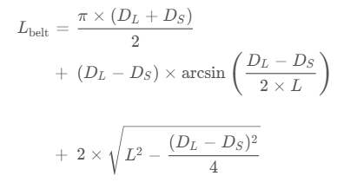
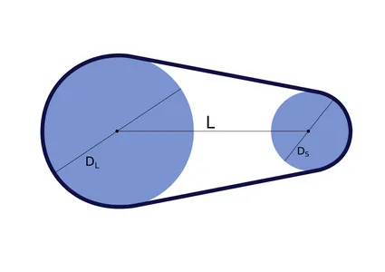
To calculate the belt length of a belt for a two pulley system, we only need to know three measurements.

D_{L} = D_{H} = 12 mm
L_{x} = 486 mm
L_{y} = 405.5 mm
- belt length in x-axis L_{belt} = 1009.7 mm
- belt length in y-axis L_{belt} = 848.7 mm
But due to the working principle that we use then the belt length should be used is 1791.77 mm. (this dimension is taken from SolidWorks after finishing the design)

Belt Tension
Proper tension is required to avoid slipping or sagging:
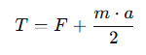
T = m*g*µ + ½ m*a = 2.6 N
where:
- T = tension in the belt.
- F = force required to move the load.
- m = total mass of the moving parts.
- a = acceleration.

Tension Capacity-Based Formula
The belt thickness ttt can be approximated for flat belts based on tensile stress:
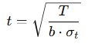
t = 0.011 m = 11 mm
Where:
- T: Maximum tension in the belt (N).
- b: Belt width (m). = 6mm
- σt: Allowable tensile stress of the belt material (Pa). = 3448378.65 Pa

Motion Profile
Angular Velocity:
W_{max} = V/r_{pulley} = 0.3/0.006 = 50 rad/sec

Angular Acceleration:
α_{max} = w_{max} / t = 50/0.33 = 151.5 rad/sec²
Inertia

Motor & Load side pulley inertia:
J_{pm} = J_{l} = ½ m_{pulley} *r_{pulley}² = ½ * 0.0054 * 0.006² = 9.72x10⁻⁸ Kg.m²

Load side pullet inertia reflected to Motor:
J_{pl--m} = (J_{pl} / e)(1/N_{r})² = (9.72x10⁻⁸ / 0.9) (1/1)² = 1.08x10⁻⁷ Kg.m²

Belt inertia reflected to Motor:
J_{B—m} = (m_{B}*r²)/ e = (0.017*0.006²) / 0.5 = 6.8x10⁻⁷ Kg.m²

Load inertia reflected to Motor:
J_{L—m} = (m_{L} * r²) / e = (0.5 * 0.006²) / 0.9 = 2x10⁻⁵ Kg.m²

Total inertia:
J_{total} = J_{pm} + J_{pl—m} + J_{B—m} + J_{L—m} = 2.09x10⁻⁵ Kg.m²

Torque required

Torque due to constant motion: T_{C} = T_{friction} = m_{load} * g * µ * r_{pulley} = 0.5 * 9.81 * 0.5 * 0.006 = 0.015 Nm
µ : friction coefficient (0.3 – 0.5)

Torque due to acceleration: T_{a} = α_{max} * J_{total} = 151.5 * 2.09x10⁻⁵ = 3.2x10⁻³ Nm
T_{max} = T_{c} + T_{a} = 0.015 + 3.2x10⁻³ = 0.2 Nm
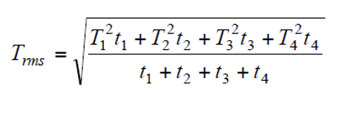
Torque rms: T_{rms} = 0.15 Nm

Ta + Tc

then the required torque of motor is 0.2 Nm

Step Resolution
To calculate the linear movement per step of the stepper motor:
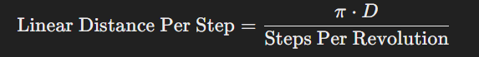
Where:
- D: Diameter of the pulley
- Steps Per Revolution: Number of steps in one motor revolution (e.g., 200 for a 1.8° stepper motor).
If micro stepping is used, adjust the resolution accordingly.

